Ontario Highway 401

Traffic Jams

Mohammed Al-Fakhri  
 ES&C  
 University of Guelph  
 Guelph, Ontario, Canada  
 malfakhr@uoguelph.ca

ABSTRACT

Traffic jams continue to remain a problem in our modern days. Most well developed cites like Toronto and Dubai gets supper busy during work hours. Due to the high rent in these cities people tend to move out of the city to save couple of dollars. This causes going to work only possible through highways. Which leads to intense traffic congestions as shown in figure 1. These traffic congestion have an average annual delay of 4,358,000 hrs on the highway 401 as mentioned by the CAA[1].

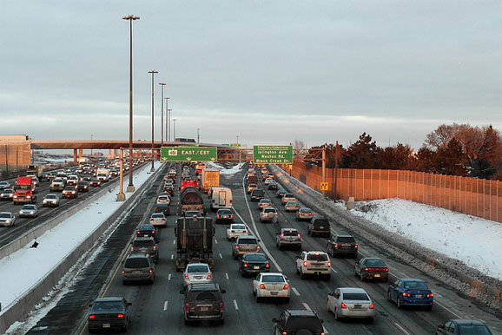

Figure 1: Highway 401 during rush hours.

As mentioned before these traffic jams are caused by many different reasons. One of the main reasons is that there are too many cars for the roadway, another reason is that these types of highways require a lot of maintenance which causes a mass of construction zones. Last but not least, car/truck crashes which causes either a half block or a full block on the highway depending on the severity of the crash, on highways the average time it takes to clear a crash site is 90 min.

A lot of research papers are available online for traffic jams solutions. But this paper will be directed to simulating traffic jams on highway 401 specifically and the best ways to solve this problem in a systematic point of view.

The Think Complexity book talks about traffic jams in chapter 10[2] . It talks about spontaneous traffic jams and the way people behavior can cause these traffic jams without reaching the limit of vehicles on the highway.

Some limitation & assumption to consider about this system is:

* That the highway has an infinite distance.
* That the highway will not have any crashes but when it will detect when a possible crash is going to happen and dodges it.
* Highway 401 has a continuous 4 lanes in each direction.
* All test will run for 300 ticks.

1 Simulation Model 1

The first model that will be used to run simulation with is powered by NetLogo Web[3]. The model used is available in sample models section social science and specifically the Traffic 2 lanes( <https://bit.ly/2y7sIdj> ). The model specification is shown in Table 1. This model will use two traffic lanes for simplicity. The answer can then be multiplied to get the correct numbers for 4 lanes. This model also allows us to follow the car to check the behavior of that specific car and the affects of other vehicles on it.

Table 1: Specifications of Model 1

|  |  |
| --- | --- |
| Number of Cars | Controls the number of cars on the road. |
| Acceleration | The rate at which cars accelerate when there are no cars ahead. |
| Deceleration | The rate at which cars decelerate when there are is a car ahead. |
| Max Patience | How many times a car can slow down before a driver loses their patience and tries to change lanes. |

1.1 Patience Vs Amount of Vehicles

The first simulation is testing the patience of driver while going through different number of cars and checking the affect of changing lanes on the traffic flow. While setting acceleration at 0.005 and deceleration at 0.02. Test 1 runs at 20 cars on the road and with a patience level of 20%.

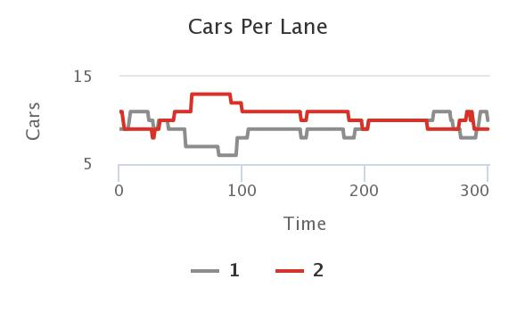

Figure 2: Cars in lane Vs Time

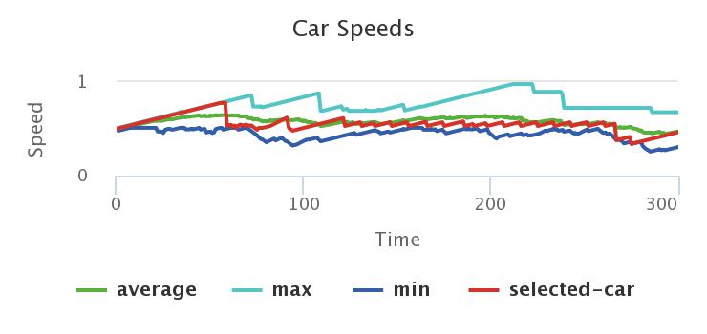

Figure 3: Speed vs Time

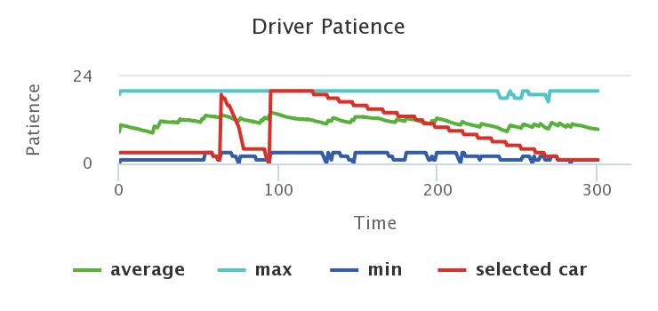

Figure 4: Patience Vs Time

As can be seen in simulation results Figure 4 the car that we selected changed lanes once at approximately 130 ticks. This change in lane didn’t make any type of traffic jam, the flow kept going as seen in Figure 3 in which speed of the red car stayed the same as the average speed of the highway.

Running the same simulation but with 5% patience. As shown in Figure 5 & 7, the selected car kept changing lanes and the number of cars per lanes kept changing. These results show that increase in lane changing will cause the average speed of the cars to decrease causing traffic congestions over time. The affect of average speed decreasing can be seen can be seen in figure 6.

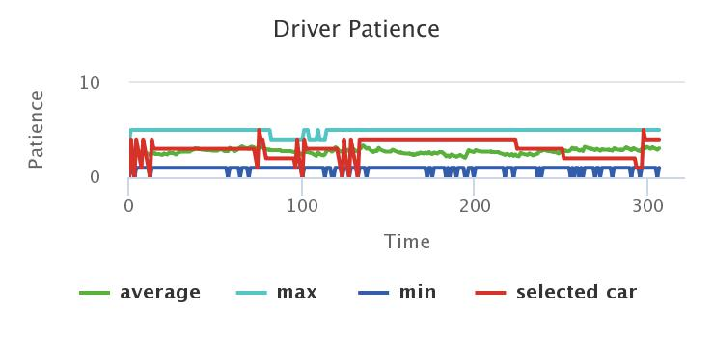

Figure 5: Patience Vs Time test #2

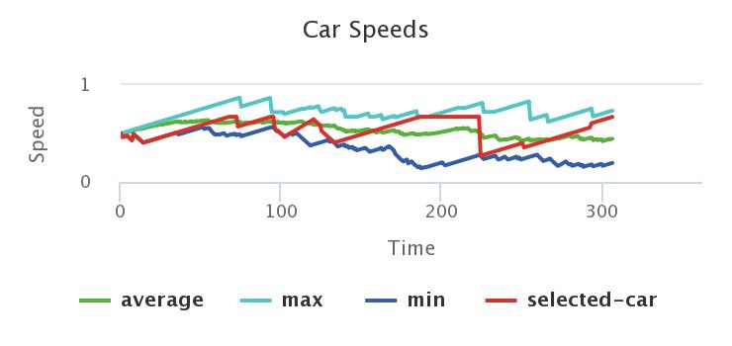

Figure 6: Speed Vs Time Test #2

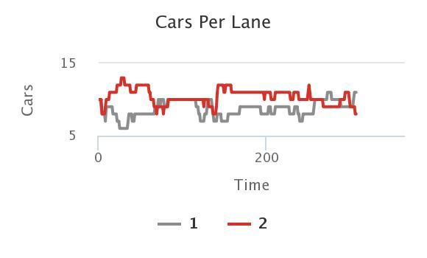

Figure 7: Cars in lane Vs Time Test #2

The 3rd simulation is with running the same patience levels as the previous tests but this time with number of cars on the road increased to 30. Running the two simulations, it can be noticed that the simulation with higher percentage of patience will run for longer until a traffic congestion occurs as shown in Figure 8 and 9. It can also be noticed that the traffic jam with a 5% patience has a low average speed after a certain amount of time, this shows that the traffic jam is still happing. Although the simulation with 20% patience has traffic jam, but these traffic jams happen for a small amount of time and it tends to break up and go back to the normal average speed.

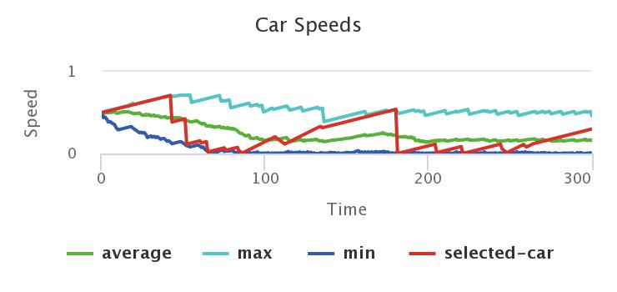

Figure 8: Speed Vs Time @ 5% patience

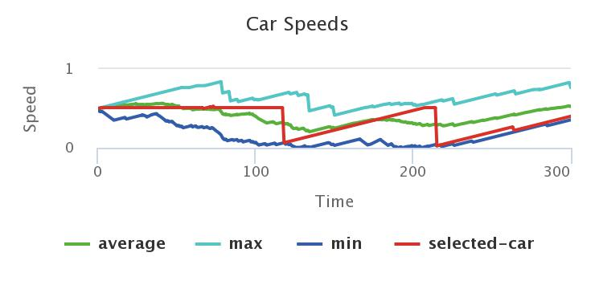

Figure 9: Speed Vs Time @ 20% patience

To conclude, these tests showed that one of the reasons for traffic jams occur is that the driver is not patient enough to stay in the same lane. Changing lanes has a great affect at the average speed of a highway as it causes the drivers to slow down and at random rate to keep safe distance and the chain goes on. This random rate deceleration will keep increasing until it reaches a point of complete stop.

1.2 Increasing number of lanes in high congestion areas.

This simulation will test the affect of increasing the number of lanes in high congestion areas. When looking at highway 401 it can be noticed that near major cities the percentage of having traffic jams increases rapidly. This can be solved easily but at the same time its costly. This simulation we will try to calculate when is it worth to increase number of lanes to decrease the traffic jams.

It is important to understand that increasing number of lanes are costly, they can coast around $1 to $2 million dollars per mile to build a single lane. This solution can only be done if it decreases the amount of traffic jams significantly.

To simulate this case, a system of four lanes was created with an assumption that drivers have high patience and accelerate and decelerate perfectly depending on the condition. A simulation was done with 130 cars to demonstrate it as shown in figure 10. This traffic jam decreases the average speed from 50 km/Hr to around 15 Hm/ Hr as shown in figure 11.

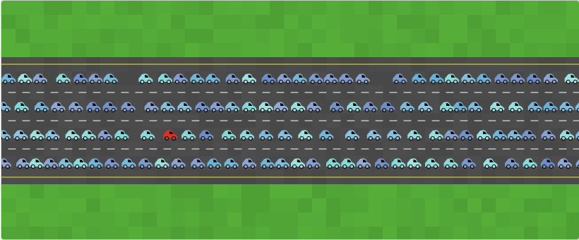

Figure 10: Traffic condition @ 130 cars & 4 lanes

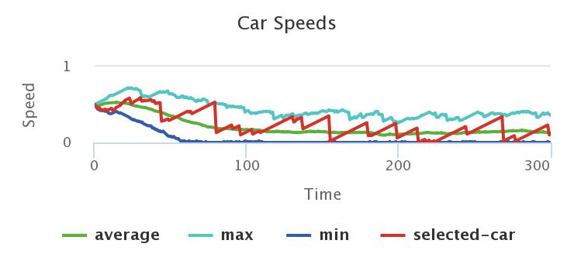

Figure 11: Speed Vs Time @ 130 cars & 4 lanes

This causes a huge traffic jam, if the province adds two lanes to the highway this will decrease the intensity of the traffic jams and this can be seen in figure 12 & 13. The addition of the two lanes makes the highway stable and the average speed is the same as the selected speed limit is. This will also increase the highway capacity in that area from 130 cars to 180 cars until we reach the point where the speed is 15 Km/Hr again. This addition will cost around $2 to $4 million dollars per kilometer.

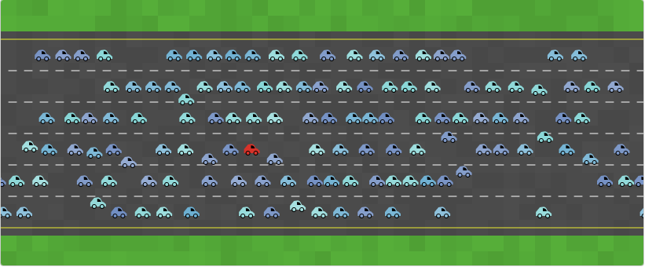

Figure 12: Traffic condition @ 130 cars and 6 lanes

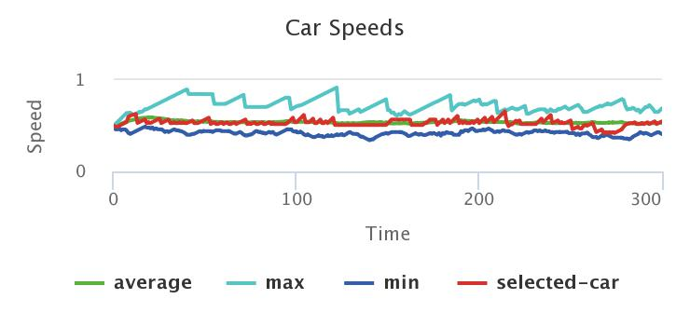

Figure 13: Speed Vs Time @ 130 cars & 6 lanes

*1.1.1 Heading Level 3.* Insert paragraph text here. Insert paragraph text here. Insert paragraph text here. Insert paragraph text here. Insert paragraph text here. Insert paragraph text here. Insert paragraph text here. Insert paragraph text here. Insert paragraph text here. Insert paragraph text here. Insert paragraph text here.

*1.1.1.1 Heading Level 4.*Insert paragraph text here. Insert paragraph text here. Insert paragraph text here. Insert paragraph text here. Insert paragraph text here. Insert paragraph text here. Insert paragraph text here. Insert paragraph text here. Insert paragraph text here. Insert paragraph text here. Insert paragraph text here.

ACKNOWLEDGMENTS

Insert paragraph text here. Insert paragraph text here. Insert paragraph text here. Insert paragraph text here. Insert paragraph text here. Insert paragraph text here. Insert paragraph text here. Insert paragraph text here. Insert paragraph text here. Insert paragraph text here. Insert paragraph text here.

REFERENCES

[1] Anon. 2017. Evaluating Canada's Worst Bottlenecks. Grinding to a Halt (January 2017), 1–88.

[2] Allen Downey. 2018. Think complexity: complexity science and computational modeling, Beijing: OReilly.

[3] Wilensky, U. & Payette, N. (1998). NetLogo Traffic 2 Lanes model. http://ccl.northwestern.edu/netlogo/models/Traffic2Lanes. Center for Connected Learning and Computer-Based Modeling, Northwestern University, Evanston, IL.

[4] David Kosiur. 2001. *Understanding Policy-Based Networking* (2nd. ed.). Wiley, New York, NY..

Conference Name:ACM Woodstock conference

Conference Short Name:WOODSTOCK’18

Conference Location:El Paso, Texas USA

ISBN:978-1-4503-0000-0/18/06

Year:2018

Date:June

Copyright Year:2018

Copyright Statement:rightsretained

DOI:10.1145/1234567890

RRH: F. Surname et al.

Price:$15.00